Our communication needs for the project included easy access to screensharing, the ability to contact each other on short notice and host team meetings.

For the first meeting of our project, we used Microsoft Teams, as that was what we had used previously during class. However, from the second day onwards, we switched to using our previously created Discord server. This communication channel was chosen because it’s easy to share files and screenshare, and all the team members regularly use Discord as a messaging app so we’re all familiar with it. Discord’s user pinging feature also allows us to notify each other quickly, ensuring that no message is missed.

We used the Discord server channels to share information and files, as well as update the team on what parts of the project we’ve completed or errors we ran into. We had meetings in Discord voice channels two or three times every week to discuss what we plan to work on and other important details. We also wrote meeting minutes for a few of the calls, though most of the time it wasn’t necessary.

One of the issues we encountered while coding this project was dealing with collaborative coding and merge conflicts. We decided to allocate certain files or timeframes to team members at the end of meetings so that we wouldn’t accidentally edit the same files at the same time. This method was very effective and we didn’t have any merge conflicts throughout the project.

**Communication evidence**

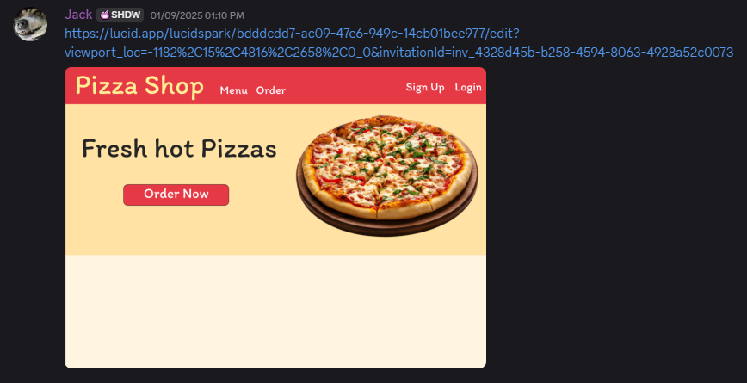

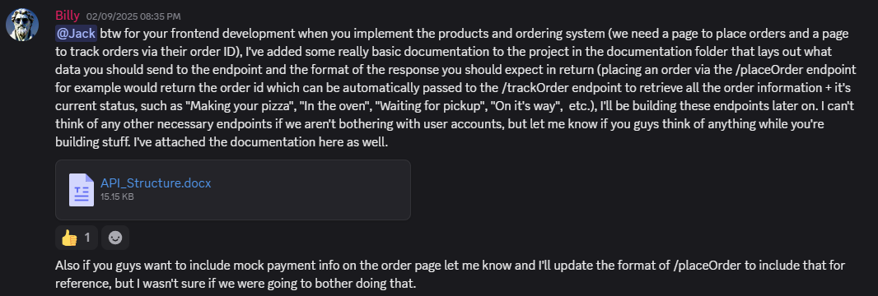

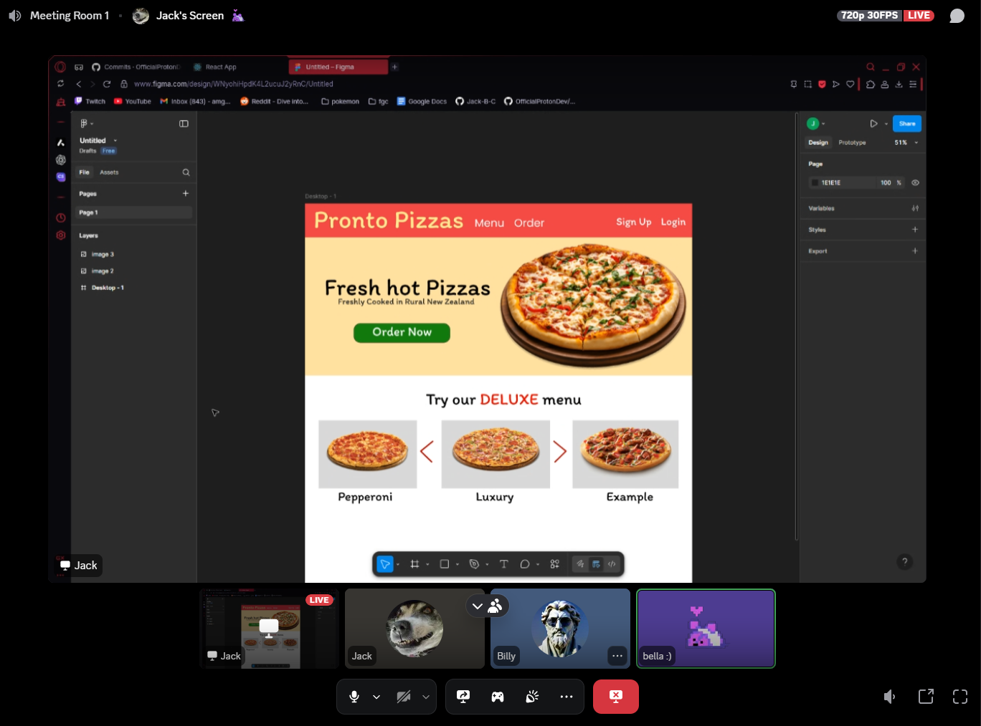

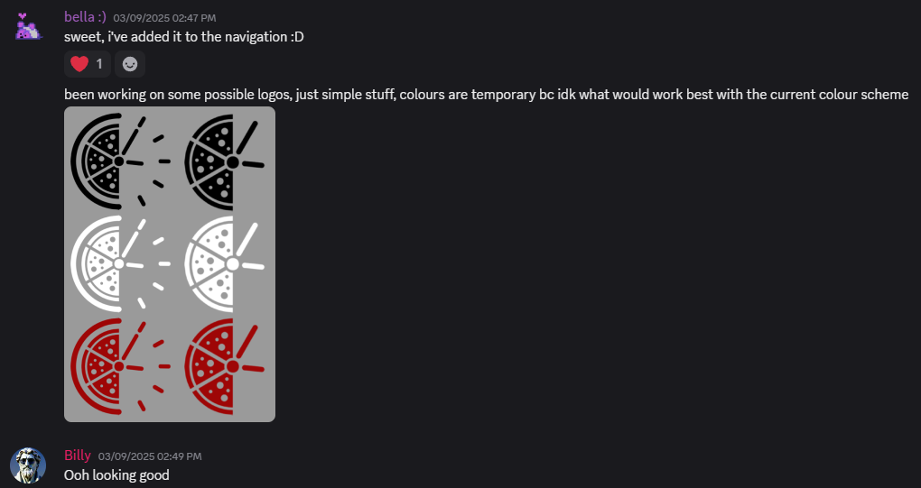

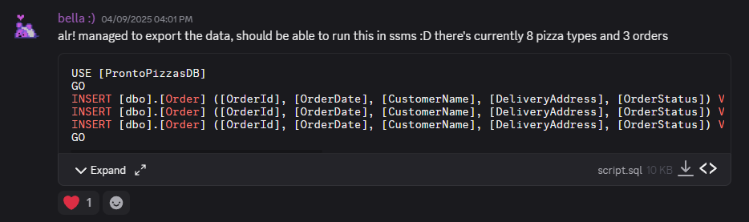

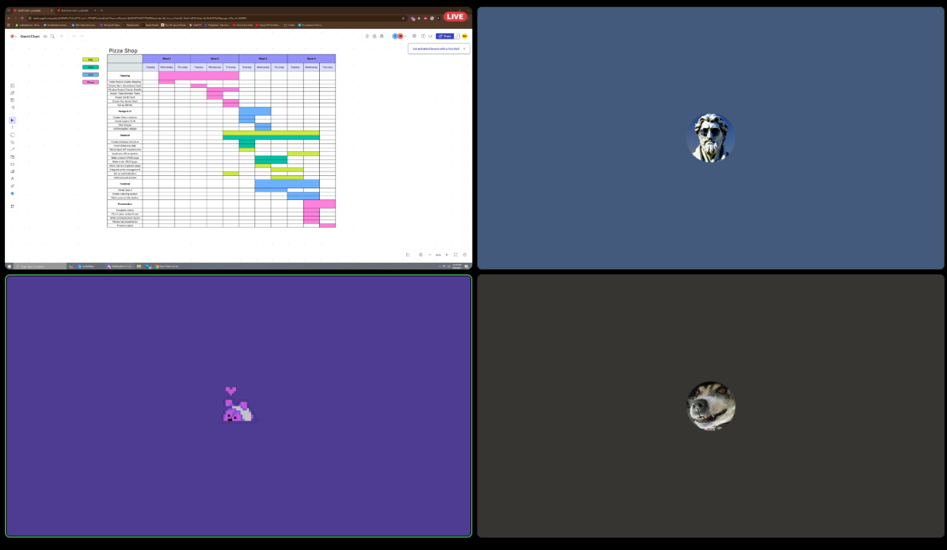

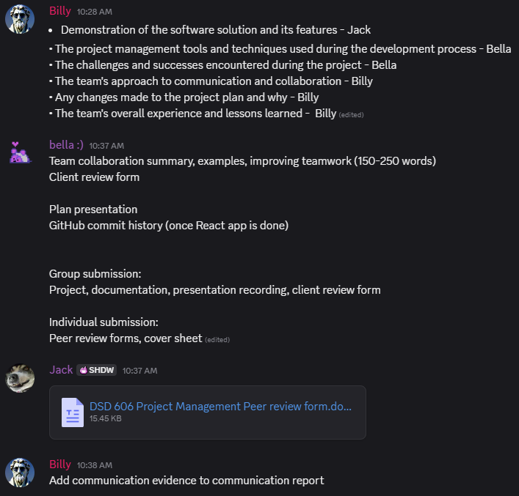

Meeting Minutes

Date & Time: 20/8/2025 10:am – 11:am

# Attendees

Billy, Bella, Jack.

# Decisions Made

- Decided on Tutor for our client.

- Decided on Asp.net react project.

- Decided on a Pizza ordering site, with menu and ordering system etc. Admin panel backend site to, CRUD pizzas/menu items, and manage permissions of users.

# Task Allocation

• Billy & Bella – ASP.NET Backend & Frontend

• Jack – React Backend & Frontend

# Next Meeting

Complete planning stage, including Gantt chart and burndown chart.

Meeting Minutes

Date & Time: 21/8/2025 10:am – 10:am

# Attendees

Billy, Bella, Jack.

# Decisions Made

* Made Burndown chart
* Made Gantt Chart
* Created work breakdown chart
* Decided on frontend color scheme and layout.
* Completed planning stage.

# Next Meeting

Update each other on progress on React Frontend, and ASP.net panel.

Meeting Minutes

Date & Time: 11/9/2025 10:am – 1:pm

# Attendees

Billy, Bella, Jack.

# Decisions Made

* Finished programming project
* Planned group presentation

# Next Meeting

Present.